Overview of SpringData
Spring Data is a powerful Spring framework module designed to simplify database access in Java applications. It provides a consistent programming model for different data stores (SQL, NoSQL, and distributed systems).
The main goal of Spring Data is to:
✔ Reduce boilerplate code
✔ Provide abstractions for data access
✔ Make working with databases easier and faster
✔ Provide automatic repository implementations

Unified Repository Abstraction
Spring Data provides CrudRepository, JpaRepository, PagingAndSortingRepository, etc.
You only write interfaces, and Spring Data creates the implementation automatically.
Example:
public interface EmployeeRepository extends JpaRepository<Employee, Integer> {
}
No need to write DAO implementations!

Query Method Naming
Spring Data generates queries using method names.
Example:
List<User> findByEmail(String email);
List<User> findByAgeGreaterThan(int age);

Custom JPQL / SQL Queries
You can manually define queries:
@Query("select u from User u where u.name = :name")
User getUserByName(@Param("name") String name);

Pagination and Sorting
Built-in support for paging and sorting:
Page<User> users = repo.findAll(PageRequest.of(0, 5, Sort.by("name")));
Integration with Multiple Database Types
Spring Data supports:
Relational Databases
- Spring Data JPA
- Spring Data JDBC
- Spring Data R2DBC
NoSQL Databases
- MongoDB
- Cassandra
- Redis
- Couchbase
- Neo4j
- Elasticsearch

Transaction Management
Strong integration with Spring’s @Transactional support.

Relationship between JPA, Hibernate, and Spring Data JPA
1. JPA (Java Persistence API) → Specification
✔ JPA is not a framework
✔ It is a standard specification (a set of rules and interfaces) for ORM in Java
✔ It defines how Java objects should be mapped to database tables
But it does NOT provide implementation — only guidelines.
Examples of JPA interfaces:
EntityManager, Entity, PersistenceContext
JPA = What to do (rules)
Not responsible for actual SQL generation
2. Hibernate → Implementation of JPA
✔ Hibernate is a framework
✔ It provides the actual implementation of JPA
✔ Hibernate executes SQL queries, manages sessions, and interacts with the database.
Hibernate does everything that JPA requires — and more:
- Lazy loading
- Caching
- HQL (Hibernate Query Language)
- Criteria API
- Advanced performance optimizations
Hibernate = How to do it (implementation)
It sits underneath JPA.

3. Spring Data JPA → Abstraction on top of JPA & Hibernate
Spring Data JPA:
- Makes JPA/Hibernate easier to use
- Removes boilerplate code
- Creates repository implementations automatically
You only write an interface:
public interface UserRepository extends JpaRepository<User, Long> {}
Spring Data JPA will:
- Generate the implementation
- Use JPA (standard API)
- Use Hibernate internally (default provider)
Spring Data JPA = Simplifies JPA + Hibernate
It uses Hibernate (or another provider) behind the scenes.

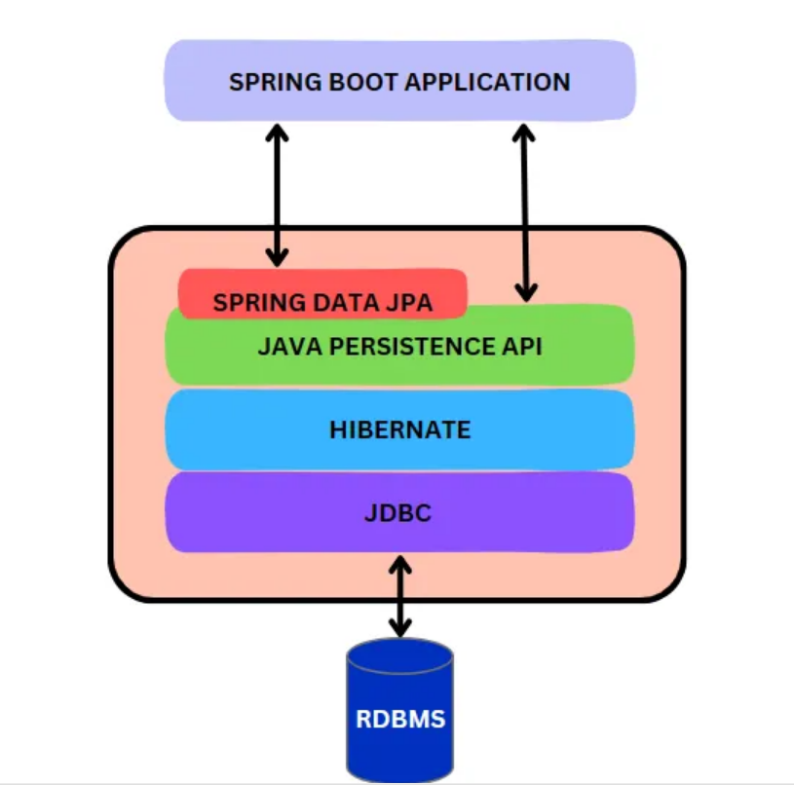

JpaRepository vs CrudRepository
Both are part of Spring Data and provide ready-made repository methods, but they differ in features and use cases.
1. CrudRepository (Basic CRUD)
✔ Provides basic CRUD operations only:
- save()
- findById()
- findAll()
- delete()
- deleteById()
✔ Very basic and lightweight
✔ Suitable for simple systems or NoSQL implementations
Key Methods:
<S extends T> S save(T entity);
Optional<T> findById(ID id);
Iterable<T> findAll();
void deleteById(ID id);

2. JpaRepository (Advanced JPA Features)
JpaRepository extends PagingAndSortingRepository, which extends CrudRepository.
So JpaRepository = CRUD + Paging + Sorting + JPA-specific methods.
✔ Adds advanced JPA operations
✔ Adds pagination
✔ Adds batch operations
✔ Adds flush and saveAndFlush
✔ Adds deleteInBatch
✔ Adds JPA-specific features
Additional Methods:
List<T> findAll();
List<T> findAll(Sort sort);
Page<T> findAll(Pageable pageable);
void flush();
T saveAndFlush(T entity);
void deleteInBatch(Iterable<T> entities);

Property Expressions
Property Expressions are a powerful feature in Spring Data that allow you to create queries automatically by defining method names in your repository interface — without writing JPQL or SQL.
Spring analyzes the method name, reads the property names in your entity, and dynamically forms a query.

Example Entity
@Entity
public class Employee {
private Long id;
private String name;
private String email;
private int age;
private Address address; // nested object
}
Example Property Expression
List<Employee> findByName(String name);
Write in repository interface, call in service , as well as in controller
Spring Data generates:
SELECT * FROM employee WHERE name = ?;
No manual query required.

How Property Expressions Work
Method name format:
findBy + <PropertyName> + <Operator>
Spring splits the method name into:
- Query keywords (findBy, getBy, readBy, queryBy)
- Properties (name, email, age, address.city)
- Operators (Like, Between, GreaterThan, In, IgnoreCase…)

Supported Keywords (Most Common)
✔ Equality
findByName(String name);
findByEmail(String email);
✔ AND Conditions
findByNameAndAge(String name, int age);
✔ OR Conditions
findByNameOrEmail(String name, String email);
✔ Comparisons
findByAgeGreaterThan(int age);
findByAgeLessThan(int age);
findByAgeBetween(int start, int end);
✔ LIKE queries
findByNameLike(String pattern);
findByNameContaining(String keyword);
findByNameStartsWith(String prefix);
findByNameEndsWith(String suffix);
✔ Sorting in method name
findByAgeOrderByNameAsc(int age);
findByAgeOrderByNameDesc(int age);
✔ Ignore case
findByNameIgnoreCase(String name);
✔ Boolean
findByActiveTrue();
findByActiveFalse();
✔ IN queries
findByNameIn(List<String> names);

Nested Property Expressions
Spring allows navigation into related objects:
Example:
findByAddressCity(String city);
Equivalent SQL:
SELECT * FROM employee e
JOIN address a ON e.address_id = a.id
WHERE a.city = ?

Complete Example Repository
public interface EmployeeRepository extends JpaRepository<Employee, Long> {

List<Employee> findByName(String name);
List<Employee> findByAgeGreaterThan(int age);
List<Employee> findByNameAndEmail(String name, String email);
List<Employee> findByAddressCity(String city);
List<Employee> findByNameIgnoreCase(String name);
List<Employee> findByAgeBetween(int min, int max);
}
Task for you….
Below are the core annotations used for entity mapping, repositories, relationships, and lifecycle events.
1. Entity-Level Annotations
@Entity
Marks a Java class as a JPA entity (mapped to a database table).
@Entity
public class Employee { }

@Table(name = "employees")
Specifies custom table name and properties.
@Entity
@Table(name = "employees")
public class Employee { }

2. Field-Level Annotations (Column Mapping)
@Id
Marks a field as the primary key.
@Id
private Long id;

@GeneratedValue(strategy = GenerationType.IDENTITY)
Automatically generates primary key values.
Strategies:
- AUTO
- IDENTITY
- SEQUENCE
- TABLE

@Column(name = "emp_name", nullable = false, unique = true)
Controls column settings.

@Transient
Field is ignored — not stored in the database.

@Transient
private int temporaryValue;

3. Relationship Annotations
@OneToOne
One-to-one relationship.
@OneToOne
private Address address;

@OneToMany
One record → many records (parent side).
@OneToMany(mappedBy = "employee")
private List<Phone> phones;

@ManyToOne
Many records → one record (child side).
@ManyToOne
private Department department;

@ManyToMany
Many-to-many relationship.
@ManyToMany
private List<Project> projects;

@JoinColumn(name = "dept_id")
Specifies foreign key column.

@JoinTable
Used in ManyToMany to define join table.

4. Repository Annotations
@Repository
Marks a class as Data Access Layer and enables:
- Exception translation
- Automatic component scanning
Spring Data repositories typically don't need it because they are auto-stereotyped.

5. Query Annotations
@Query
Used to write custom JPQL or native SQL queries.
@Query("select e from Employee e where e.name = :name")
List<Employee> findByName(@Param("name") String name);

@Modifying
Used with update or delete queries.
@Modifying
@Query("update Employee e set e.active=false where e.id=:id")
void deactivateEmployee(int id);

@Param
Used to bind method parameters to query parameters.
@Param("name") String name

@Transactional
Used to manage transactions for repository methods.

Lifecycle Callback Annotations
Inside Entity:
@PrePersist
Called before entity is inserted.
@PostPersist
After insert.
@PreUpdate
Before update.
@PostUpdate
After update.
@PreRemove
Before delete.
@PostRemove
After delete.
@PostLoad
When entity is fetched from DB.

Transaction Management
ACID Properties of a Transactions
What Is a Transaction?
A transaction is a unit of work in a database operation that must follow ACID properties:
- Atomicity → all or none
- Consistency → valid state before and after
- Isolation → no interference between transactions
- Durability → changes persist after commit

Purpose of @Transactional
Using this annotation, Spring:
✔ Starts a transaction
✔ Executes your method
✔ Commits if successful
✔ Rolls back automatically if an exception occurs

@Service
public class EmployeeService {
@Transactional
public void updateEmployee(Employee emp) {
// multiple DB operations
}
}

Unit testing with Mockito
Service layer typically contains:
- Business logic
- Repository calls (DB interactions)
- Validation
- Transformations
- Exception handling
Goal of unit testing:
👉 Test only service logic
👉 Do NOT hit database
👉 Mock repository using Mockito

2. Dependencies (Maven)
<dependency>
<groupId>org.mockito</groupId>
<artifactId>mockito-core</artifactId>
<version>5.8.0</version>
<scope>test</scope>
</dependency>

<dependency>
<groupId>org.junit.jupiter</groupId>
<artifactId>junit-jupiter</artifactId>
<version>5.10.0</version>
<scope>test</scope>
</dependency>

3. Sample Entity
public class User {
private Long id;
private String name;
private String email;

// getters, setters, constructors
}

4. Repository
public interface UserRepository extends JpaRepository<User, Long> {
Optional<User> findByEmail(String email);
}

5. Service Layer
We'll test this service.
@Service
public class UserService {

@Autowired
private UserRepository userRepository;

public User getUserById(Long id) {
return userRepository.findById(id)
.orElseThrow(() -> new RuntimeException("User not found"));
}

public User createUser(User user) {
Optional<User> existingUser = userRepository.findByEmail(user.getEmail());
if (existingUser.isPresent()) {
throw new RuntimeException("Email already exists");
}
return userRepository.save(user);
}
}

6. Unit Testing the Service Layer (JUnit + Mockito)
✔ We need to mock:
@Mock
private UserRepository userRepository;
✔ Inject service:
@InjectMocks
private UserService userService;

7. Complete Test Class
Using JUnit 5 and Mockito.
@ExtendWith(MockitoExtension.class)
public class UserServiceTest {

@Mock
private UserRepository userRepository;

@InjectMocks
private UserService userService;

// --------- Test Get User By ID (Success) ----------
@Test
void testGetUserById_success() {

User user = new User(1L, "John", "john@gmail.com");

Mockito.when(userRepository.findById(1L))
.thenReturn(Optional.of(user));

User result = userService.getUserById(1L);

assertNotNull(result);
assertEquals("John", result.getName());
assertEquals("john@gmail.com", result.getEmail());

Mockito.verify(userRepository, times(1)).findById(1L);
}

// --------- Test Get User By ID (Exception) ----------
@Test
void testGetUserById_userNotFound() {

Mockito.when(userRepository.findById(1L))
.thenReturn(Optional.empty());

RuntimeException ex = assertThrows(RuntimeException.class, () ->
userService.getUserById(1L)
);

assertEquals("User not found", ex.getMessage());
}

// --------- Test Create User (Success) ----------
@Test
void testCreateUser_success() {

User user = new User(null, "John", "john@gmail.com");

Mockito.when(userRepository.findByEmail("john@gmail.com"))
.thenReturn(Optional.empty());

Mockito.when(userRepository.save(user))
.thenReturn(new User(1L, "John", "john@gmail.com"));

User result = userService.createUser(user);

assertNotNull(result);
assertEquals(1L, result.getId());
}

// --------- Test Create User (Email Exists) ----------
@Test
void testCreateUser_emailExists() {

User existing = new User(1L, "John", "john@gmail.com");
User newUser = new User(null, "John", "john@gmail.com");

Mockito.when(userRepository.findByEmail("john@gmail.com"))
.thenReturn(Optional.of(existing));

RuntimeException ex = assertThrows(RuntimeException.class, () ->
userService.createUser(newUser)
);

assertEquals("Email already exists", ex.getMessage());
}
}

